Project 4: Subdomain Enumeration Tool (SAFE & ETHICAL)
Name of Intern: Sahasra Chandhana Reddigari
Intern ID: ITID5926
Internship Organization: InLighnX Global Pvt. Ltd.
Internship Title: Offensive Cybersecurity Internship
Internship Duration: 15/11/2025 to 15/02/2026
Objective
The objective of this project is to understand the concept of subdomain enumeration using DNS resolution in a safe and ethical manner.
Subdomain enumeration is a technique used in cybersecurity to discover subdomains associated with a main domain. It helps security professionals understand the attack surface of a domain.
This project uses the official test domain example.com to ensure ethical and legal execution.
Tools and Technologies Used
- Programming Language: Python
- Library Used: socket
- Platform: Windows

Implementation
The tool uses Python’s socket library to perform DNS resolution.
A predefined list of common subdomains is combined with the main domain.
Each subdomain is checked using socket.gethostbyname().
If the subdomain exists, its IP address is displayed.
PYTHON CODE SNIPPET:
"""
Subdomain Enumeration Tool (Safe Version)
Internship Project 4

This script checks common subdomains for a SAFE test domain
using DNS resolution.

Domain used: example.com (official test domain)
"""

import socket

def enumerate_subdomains(domain, subdomains):
print(f"\nStarting subdomain enumeration for: {domain}\n")
found_count = 0

for sub in subdomains:
full_domain = f"{sub}.{domain}"
try:
ip = socket.gethostbyname(full_domain)
print(f"[FOUND] {full_domain} -> {ip}")
found_count += 1
except socket.gaierror:
# Subdomain does not exist
pass

return found_count

def main():
# SAFE test domain
domain = "example.com"

# Common subdomain list
subdomain_list = [
"www",
"mail",
"ftp",
"test",
"dev",
"blog",
"api"
]

total_found = enumerate_subdomains(domain, subdomain_list)

print("\nEnumeration Completed.")
print(f"Total subdomains found: {total_found}")

if __name__ == "__main__":
main()

RUNNING THE PROJECT:
- Save the script as subdomain_enum.py
- Open Command Prompt
- Navigate to the project directory
- Run the command: python subdomain_enum.py
- Observe the output
Implementation Screenshots:
1. Code Implementation: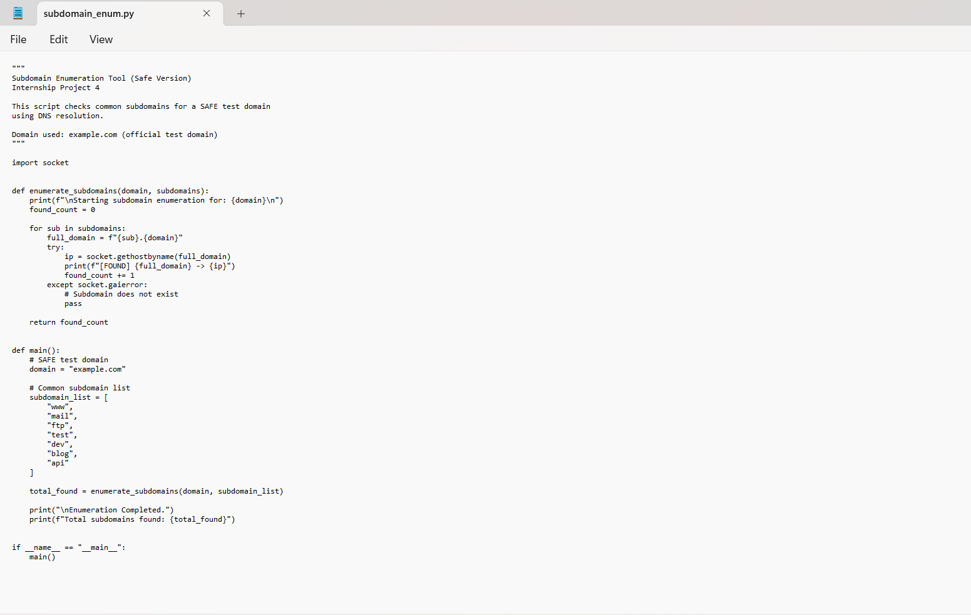
2. Command Line Output:
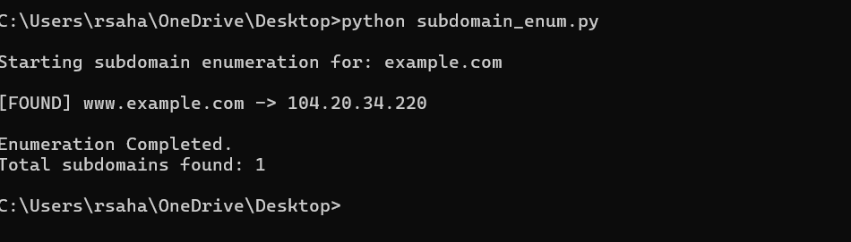
3. Project Folder Structure:
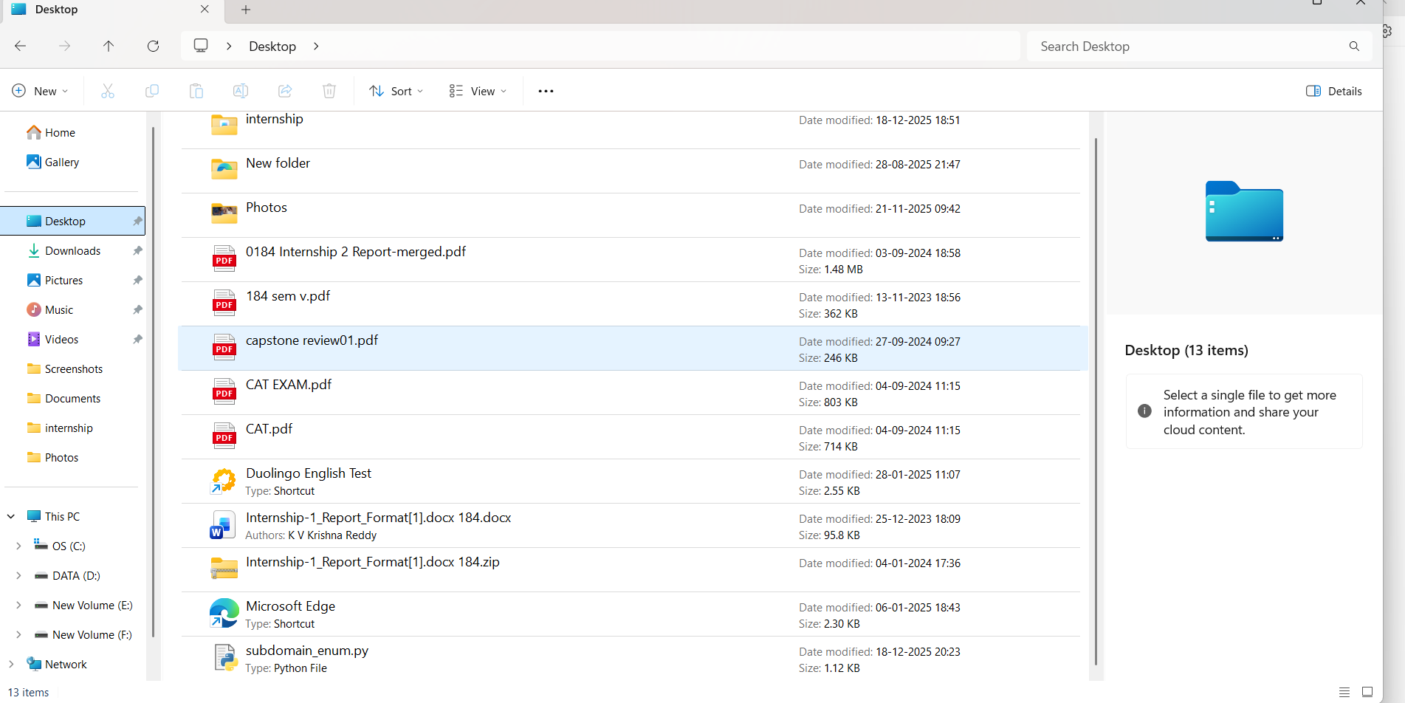
Result:
The program successfully identified the active subdomain www.example.com and displayed its IP address.
ETHICAL CONSIDERATION:
This project strictly follows ethical hacking principles.
Only the official test domain example.com was used for subdomain enumeration.
No real organization, commercial website, or unauthorized domain was scanned.
The purpose of this project is purely educational and intended to understand
DNS resolution techniques without causing any harm or security risk.
Conclusion:
This project demonstrates a simple and ethical approach to subdomain enumeration using Python and enhances understanding of DNS resolution in cyber security

